**OBJECT ORIENTED PROGRAMMING LAB**

**Experiment No: 12**

**Name: Sreelakshmi Madhusoodhanan**

**Roll No:39**

**Batch: RMCA B**

**Date:18/05/2022**

**Aim**

Create a class ‘Employee’ with data members Empid, Name, Salary, Address and constructors to initialize the data members. Create another class ‘Teacher’ that inherit theproperties of class employee and contain its own data members department, Subjects taughtand constructors to initialize these data members and also include display function to display all the data members. Use array of objects to display details of N teachers.

**Procedure**

import java.util.Scanner;

class Employee

{

int EmpId;

String EmpName;

double Salary;

String Address;

Employee(int empid,String empname,double salary,String address)

{

EmpId=empid;

EmpName=empname;

Salary=salary;

Address=address;

}

}

class Teacher extends Employee

{

String deptname,subject;

Teacher(int empid,String empname,double salary,String address,String deptname,String subject)

{

super(empid,empname,salary,address);

this.deptname=deptname;

this.subject=subject;

}

void display()

{

System.out.println(" EMPLOYEE INFORMATION\n");

System.out.println(" EMPLOYEE ID: "+EmpId);

System.out.println(" NAME : "+EmpName);

System.out.println("ADDRESS: "+Address);

System.out.println(" SALARY: "+Salary);

System.out.println("DEPARTMENT : "+deptname);

System.out.println(" SUBJECT TAUGHT: "+subject);

}

}

public class InheritanceSample

{

public static void main(String args[])

{

Scanner sc=new Scanner(System.in);

String empname,address;

double salary;

int empid;

int i,n;

String dept,subject;

Teacher[] ob;

System.out.println("\n How many records you want to insert: ");

n=sc.nextInt();

ob=new Teacher[n];

System.out.println("\nEnter details of "+n+" employees:\n");

for(i=0;i<n;i++)

{

System.out.println(" Enter the id of employee:"+(i+1)+":");

empid=sc.nextInt();

sc.nextLine();

System.out.println("Enter the name of employee : "+(i+1)+":");

empname=sc.nextLine();

System.out.println(" Enter the address: "+(i+1)+":");

address=sc.nextLine();

System.out.println(" Enter the salary: "+(i+1)+":");

salary=sc.nextDouble();

sc.nextLine();

System.out.println(" Enter the department: ");

dept=sc.nextLine();

System.out.println(" Enter the subject taught by the employee(teacher): ");

subject=sc.nextLine();

ob[i]=new Teacher(empid,empname,salary,address,dept,subject);

}

System.out.println("\n Information of Employee\n");

for(i=0;i<n;i++)

ob[i].display();

}

}

**Output Screenshot**

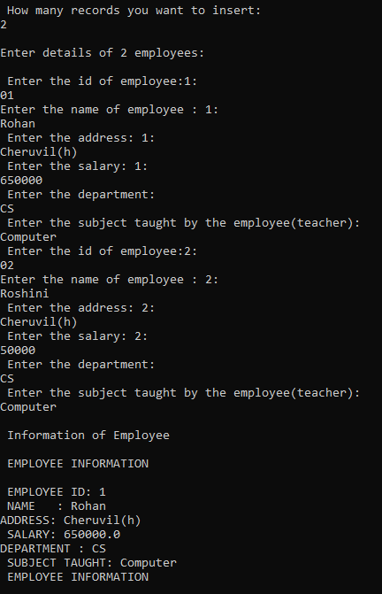

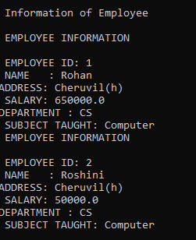

**Experiment No: 13**

**Name: Sreelakshmi Madhusoodhanan**

**Roll No:39**

**Batch: RMCA B**

**Date:18/05/2022**

**Aim**

Write a program has class Publisher, Book, Literature and Fiction. Read the information and print the details of books from either the category, using inheritance.

**Procedure**

import java.util.Scanner;

class Publisher{

String publisher;

Publisher(String pub){

this.publisher=pub;

}

}

class Book extends Publisher{

String book;

Book(String pub,String boo){

super(pub);

book=boo;

}

}

class Literature extends Book{

String category;

Literature(String pub, String boo){

super(pub, boo);

}

void display(){

System.out.println("Publisher :"+publisher);

System.out.println("Book :"+book);

}

}

class Fiction extends Book{

Fiction(String pub, String boo){

super(pub, boo);

}

void display(){

System.out.println("Publisher :"+publisher);

System.out.println("Book :"+book);

}

}

public class bookDetails{

public static void main(String[] args) {

System.out.println("Enter the No. of Literature Books:");

Scanner sc1 = new Scanner(System.in);

int num = sc1.nextInt();

Literature arr[]=new Literature[num];

System.out.println("\n Enter the Literature Book Details:");

int x = 0,j=0;

Scanner sc =new Scanner(System.in);

for(int i =0;i<num;i++)

{

x = i +1;

System.out.println(""+x+".");

System.out.println("Book : ");

String boo =sc.next();

System.out.println("Publisher: ");

String pub =sc.next();

arr[i]=new Literature(boo,pub);

}

System.out.println("\nEnter the No. of Fiction Books:");

int num1 = sc1.nextInt();

Fiction arr1[]=new Fiction[num1];

System.out.println("\n Enter the Fiction Book Details:");

int x1 = 0,j1=0;

for(int i =0;i<num1;i++)

{

x1 = i +1;

System.out.println(""+x1+".");

System.out.println(" Book : ");

String boo =sc.next();

System.out.println(" Publisher: ");

String pub =sc.next();

arr1[i]=new Fiction(boo,pub);

}

sc.close();

sc1.close();

System.out.println("\n--Informations of all the Literature Books--");

for(int i=0;i<num;i++){

j=i+1;

System.out.println("\n"+j+".");

arr[i].display();

}

System.out.println("\n--Informations of all the Fiction Books--");

for(int i=0;i<num1;i++){

j1=i+1;

System.out.println("\n"+j1+".");

arr1[i].display();

}

sc1.close();

}

}

**Output Screenshot**

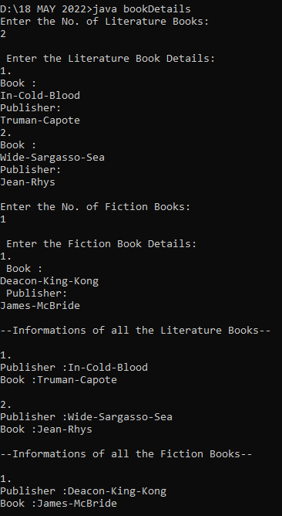

**Experiment No.: 14**

**Name: Sreelakshmi Madhusoodhanan**

**Roll No:39**

**Batch: RMCA B**

**Date:18/05/2022**

**Aim**

Create classes Student and Sports. Create another class Result inherited from Student and Sports. Display the academic and sports score of a student.

**Procedure**

import java.util.*;

import java.io.*;

interface Sports {

public void sports_getData();

public void sports_dispData();

}

class Student {

String name;

int roll_no;

float mark1, mark2;

Student(String n, int r, float m1, float m2) {

name = n;

roll_no = r;

mark1 = m1;

mark2 = m2;

}

void display() {

System.out.println("Student Details");

System.out.println("Name of Student: " + name);

System.out.println("Roll No. of Student: " + roll_no);

System.out.println("Marks of Subject 1: " + mark1);

System.out.println("Marks of Subject 2: " + mark2);

}

}

class Result extends Student implements Sports {

int r;

String item;

Scanner sc = new Scanner(System.in);

Result(String n, int r, float m1, float m2) {

super(n, r, m1, m2);

}

public void academic() {

float total = (mark1 + mark2);

float percent = total * 100 / 200;

System.out.println("___Academic Info___");

System.out.println("Percentage: " + percent + "%");

}

public void sports_getData() {

System.out.print("Enter the sports item which student participated : ");

item = sc.nextLine();

System.out.print("Enter the rank position that the obtained : ");

r = sc.nextInt();

}

public void sports_dispData() {

System.out.println("____sports Info____");

System.out.println("Item :" + item);

System.out.println("Rank :" + r);

}

}

class SportsResult {

public static void main(String args[]) throws IOException {

InputStreamReader isr = new InputStreamReader(System.in);

BufferedReader br = new BufferedReader(isr);

System.out.print("Enter the name : ");

String n = br.readLine();

System.out.print("Enter roll no : ");

int roll = Integer.parseInt(br.readLine());

System.out.print("Enter mark in first subject : ");

float m1 = Float.parseFloat(br.readLine());

System.out.print("Enter mark in second subject : ");

float m2 = Float.parseFloat(br.readLine());

Result re = new Result(n, roll, m1, m2);

re.sports_getData();

re.display();

re.academic();

re.sports_dispData();

}

}

**Output Screenshot**

